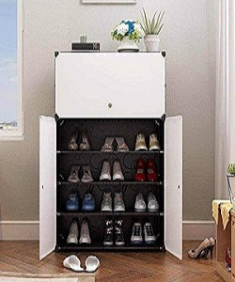

Simple Storage Cabinet

$22.87

Availability: In stock

### Description

Simple white 3 door storage cabinet. Add style and storage to any room with portable closet storage cabinet cube organizer plastic drawers. Made up of curly pure white walls back panels and pure white door panel pattern, it easily complements almost any existing décor. Save space and keep all items in one shelving. Ideal for any living room, bedroom, or small space like a crowded dorm room, it provides ample space to store toys, blankets, clothing, shoes and other items to keep them neat and orderly and declutter any space. Create your own storage solution in an easy way.